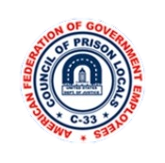

**February 2024**

Local 1298

***Special Interest Articles:***

• Presidents Report

• Legislative Update

• OWCP Common Mistakes

*Cont. on Page 2*

Brothers and sisters,

Did You Know?

Article 1 -Recognition Section b. The Employer recognizes the Union as the exclusive bargaining agent under the provisions of the Federal Service Labor Management Relations Statute, 5 USC, Chapter 71, 7101 et. seq., hereinafter referred to as “the Statute,” and the Civil Service Reform Act of 1978, of all the employees in the unit, as the recognized Union for bargaining purposes with respect to conditions of employment of employees represented by the Union. The Union has the full authority as provided by Statute to meet and confer with the Agency for the purpose of entering into negotiated agreements, concerning changes in conditions of employment covering bargaining unit employees, and to administer this Collective Bargaining Agreement. Pending National Cases:

-FMCS 210728-08778 (National Storm Leave). CPL won the arbitration (6-10-22). Agency filed an exception (late) on 7-11-22. CPL filed our opposition to the exception on 7-15-22. FLRA Case no. 0-AR-5825. Called the intake office today, and was advised it is still being considered by the panel members.

-ULP WA-CA-21-0436 (National Staffing Guidelines) was filed 9-15-21. Was notified on 1-21-22 that FLRA had found merit to the charge. Began mediation on 8-15-23 (failed), then scheduled hearing. Motions/responses submitted on 11-6-23. Waiting for a decision from ALJ. -FMCS 23045-04949 (Weekend Travel to ICT-II), grievance filed on 2-24-23. Hearing is set for June 26-27, 2024.

-ULP WA-CA-24-0060 (Bad Faith Bargaining/Failure to Publish Policies) filed 11-3-23. Accepted at FLRA

-FMCS 241215-020257 (Changes to Unit Management Policy) filed 10-20-23. set for hearing on October 10, 2024.

-FMCS Case #220712-07482 (Counselors Position Description)- New date awaiting.

-FMCS Case # 220712-07498 (Counselors Training)- August 28/29, 2024

Local Cases and Negotiations:

Local 1298 won two Summary Judgement on the following cases:

DE-CA-20-0189 Disciplinary Log.

DE-CA-0204 Workplace Violence.

Local 1298, has also

***Individual Highlights:***

CPOF 3

What is LLD? 2

Legislative Info 4

OWCP Info 5

AFGE PAC 5

Meetings 6

AFGE Local 1298 (817)534-8400 x3147

# President’s Report

## President’s Report Continued

Caption describing picture or graphic.

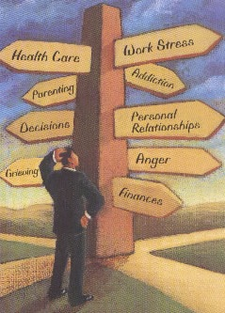

invoke to negotiate the following policies to create Institutional Supplements for our Staff at FMC Fort Worth:

Internal Affairs 1210.25

Discrimination and Retaliation Complaints Policy 3713.25

Bureau of Prisons Anti-Discrimination policy 3713.25

Reasonable Accommodation Program 3730.05

Workplace Violence Prevention 3730.

The Union has invoked to negotiate over 1 million dollars’ worth on new cameras to be installed in our institution. The Union will meet up with the Executive Staff on January 30th at 1:00 p.m., to discuss issues and how to move forward.

The Local Union receive numerus calls daily throughout the day and evening, so feel free to contact us at (817) 413-3147, or you can reach me on my cell phone, (817- 690-1695.

Remember, the more we walk and support one another Locally, In Unity and In Solidarity, the Stronger Local 1298 will continue to be success with, “A Victory For One Is A Victory For ALL!”

LLD stands for Limited Light Duty. LLD is meant to provide a temporary, not permanent, arrangement for an injured worker (IW) to continue working while recovering from an injury/illness. Examples of LLD assignments may include assignment to a position that does not require interaction with inmates or can include partial (less than eight-hour) workdays, as the needs of the inured/ill employee and the institution indicate. During the time the IW is on LLD, ample time will be provided for medical and physical therapy appointments. For routine medical appointment, a maximum of 4 hours of compensation is usually allowed. When the physicians report shows that the employee is no longer disabled, he or she is required to accept any reasonable offer of suitable light or limited duty. An offer to the IW may be made by telephone but must be confirmed in writing within 48 hours to be valid.

## What is an LLD?

A sad soul can kill you quicker than a germ. ~ John Steinbeck

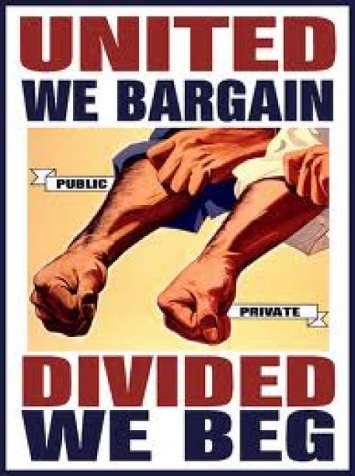

The Correctional Peace Officer Foundation’s mission statement is “is to operate and maintain a general fund for the perpetuation of the memory of those Correctional Peace Officers killed in the line of duty; to provide for their spouses, children or other beneficiaries; and to promote and project a positive image of the Corrections profession, both internally and to the general public.”

CPOF was created in 1984 by five Folsom Prison correctional officers after another officer was killed in the line of duty. The five officers observed the state not providing much for the family and wanted to do something about it.

CPOF staff work for, believe in and fight for correctional officers. Not only does CPOF assist families after a correctional officer is killed, but they provide assistance to families touched by accidents, medical crises and horrible life tragedies.

CPOF also provides additional benefits for members, including academic scholarships. How does one become a member of CPOF?

While the great majority of CPOF’s supporting membership is comprised of correctional peace officers, supporting membership is open to all who want to support the correctional series.

The Death Benefit applies to those peace officers working within the correctional series supervising in-custody adult or youth felons anywhere in the world. This includes the men and women who work within prisons, institutions and jails, or in the parole/probation systems. It’s payable to the recognized surviving family of a qualified officer murdered at the hands of an incarcerated felon or supervised parolee while on duty.

In addition to full coverage under CPOF’s Death Benefit Program, supporting members receive automatic subscription to CPOF’s publication, the CPO Family, along with informational mailings and other periodic mailings of various items, and materials designed exclusively for supporting members.

Consideration on a case-by-case basis by the Board of Directors for assistance in a time of crisis, bereavement, personal catastrophe or other urgent need. You can also visit their website at https://cpof.org/.

If you would like to donate, please see any E Board member for more information.

## Correctional Peace Officers Foundation (CPOF)

*On February 21, 2017, U.S. Attorney General Jeff Sessions rescinded the August 18, 2016 memorandum reduce and ultimately eliminate the use of privately operated prisons.*

Legislatively we've been hard at work for our members! Many bills are being currently introduced by our Union such as: HR5266 Interdiction of Fentanyl in Postal Mail in Federal Prisons Act, HR 3980 S 2264 Erics Law, HR130 S 459 Thin Blue Line Act, HR 472 S 645 Fighting PTSD Act, HR 354 LEOSA Reform Act, HR 1490 S 752 Preventing Violence Against Female Inmates Act, HR618 S 131 Improving Access To Workers Compensation For Injured Federal Workers Act, HR 866 FERS Cost-Of-Living-Adjustment (COLA), HR 2380 s 1047 Prison Cellphone Jamming Reform Act, HR 3199 Pay Our Correctional Officers Fairly Act, HR 3019 S 1401 Federal Prison Oversight Act, HR 4138 S 2284 Federal Prison Accountability Act. As you can see we have a lot on the table and if you would like further information on any of these bills, see any E Board member as to the content. Our Legislative Liaison is Victor Brown. He currently has 7 separate meetings scheduled with various congressional leaders discussing these bills and other topics that affect Local 1298 and FMC Fort Worth.

Creating bipartisanship is key since with all government negotiations. We are working to gain that rapport.

As always, please attend the monthly meetings to stay informed. And please help us help you - make those calls and send emails to your respective Congressman/woman. Congress has yet again extended Continued Resolution (CR) Until March 1, 2024. Our newly elected National President Brandy Moore-White has wasted no time discussing issues with Congress. United States President Joe Biden has also met with President Moore-White and recently signed a bill to prevent another government shutdown.

The best “value for money” when it comes to training members, stewards and officers is in building union solidarity, mentoring younger member and identifying specific concerns about union membership and labor. When we train our stewards-whether it’s negotiating or enforcing contracts, understanding labor law or organizing workers-we build our union and empower all workers the tools they need to win at work and with dignity in the workplace. Active, well-educated workers are our best defense against the forces of exclusion that plague the labor movement today.

## From the Treasurer

## Legislative Update

“Diversity and Inclusion are about giving value to every human being, no matter our differences. “

~ Unkown



1. No Representative: Employees attempt to navigate the OWCP process without benefit of a representative/ Coordinator who has experience and can advocate on their behalf. We recommend all injured federal workers if you having problems seek a representative to assist them in the process.

2. Employee Uses Leave for an Occupational Illness or Injury: A common problem is employees who use their sick leave or annual leave instead of demanding Continuation of Pay (COP) and wage loss compensation. Employees with an occupational injury (CA-1) are always entitled to COP and wage loss compensation after COP ends. Employees with an occupational illness (CA-2) are not entitled to COP, but are entitled to wage loss compensation.

3. Trusting Your Agency to File Appropriate Forms: You must not assume your supervisor or agency representative understands the process, or rely on them to file the appropriate forms in a timely manner. It is your responsibility to ensure the appropriate OWCP forms are filed timely. Although your supervisor is supposed to provide you the appropriate forms, there is no penalty for failure on the agency's part to do so, and you may lose benefits if the forms are not timely.

4. Failing to Timely Respond to Department of Labor Requests: Many injured employees fail to respond to DOL requests for information and documentation. Employees who do not respond in a timely manner risk temporary cessation of worker's compensation payments (medical and wage loss) as well as potential denial of their claim. It is vitally important to respond as quickly as possible to a DOL request.

5. Failure to Communicate with OWCP Representative: Employees who do not keep in constant communication with their chosen claim examiner / representative may inadvertently miss a timeframe, submit the wrong documentation or otherwise jeopardize their claim. It is extremely important to keep in constant touch with your representative and advise them of all correspondence you receive from DOL or the agency and any events that occur (i.e. changes or modifications in your job duties).

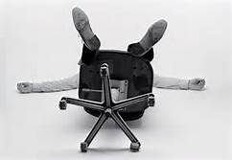

## AFGE Political Action Committee (PAC)

In a nutshell, AFGE PAC are the ones that are on the “hill”, fighting for our rights as AFGE members. They need donations from members to continue the fight. AFGE President Kelley is a strong supporter of AFGE PAC and encourages all members to participate. Every federal employee retirement and AFGE PAC will be there to fight for it. You can donate as little as $1 a paycheck. See one of your E Board members for details or questions.

## 6 COMMON MISTAKES MADE BY EMPLOYEES IN THE OWCP PROCESS

“Together, we are going to stand up for collective bargaining rights.”—Rep. Steny Hoyer, Maryland, 5th District

#### About Our Organization…

3150 Horton Rd

Fort Worth, Tx 76119

Phone:

(817) 413-3147

(817) 413-3352

(817) 413-3353

(817) 413-3354

E-Mail:

[FTW-Union-S@bop.gov](mailto:FTW-Union-S@bop.gov)

AFGElocal1298@gmail.com

We’re on the Web!

*See us at:*

[**www.afge.org**](http://www.afge.org)

[**www.cpl33.info**](http://www.cpl33.info)

**www.afge1298.com**

Monthly meetings are held once a month, rotating Wednesday/Thursday. The meeting time is 4:30pm. We also hold a drawing for a chance to win gifts and gift cards. It is imperative that you show up to the meetings to find out firsthand information that directly impacts us as bargaining unit members.

**Your E Board members are:**

**President**: Gregory Watts

**1st Vice President:**

Michael Eglinsdoerfer

**2nd Vice President:**

Victor Brown

**Treasurer:**

Chance Adams

**Secretary:**

Celina Ortiz

**Chief Steward:**

Joshua Wrich

**Sergeant at Arms:**

Jaime Diaz

**Stewards:**

Jacquelyn Baldwin

Dustin Flores

The Council of Prison Locals Local #1298 is part of the most organized Council (CPL #33) within the American Federation of Government Employees (AFGE) Organization. Local 1298 is located in Fort Worth, Texas and represents approximately 211 dues paying bargaining unit members from most departments at FMC Fort Worth.

also several tools you can use to draw shapes and symbols.

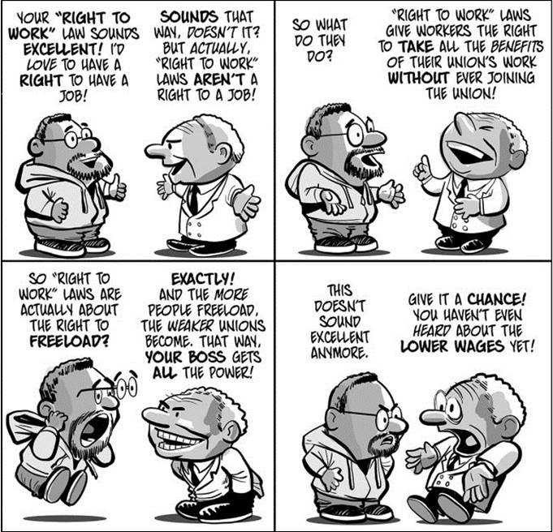

Pending Arbitrations/ULP’s

* 1 Grievance
* 2 ULP’s
* 2 Monetary Settlement Agreements

*See the President or VP’s*

*for more information*